**Vadodar**

**Dat**



Computer Programming Fundamentals

**(DI01000131)**

LABORATORY MANUAL

**Diploma Semester-I**

**Prepared By:- CE/IT Department**

**Vadodara Institute of Engineering (903) Kotambi, Vadodara – 391510**

**Academic Year : 2025-2026**

# Index

|  |  |
| --- | --- |
| **Sr No** | **Practicals** |
| **1** | Practice using scratch programming/snap programming. |
| **2** | Design and develop various problem statement using flowchart and Algorithm |
| **3** | Design and test C programs using constants, variables, data types and different operators. |
| **4** | Design and test C programs to show formatted and unformatted input and output. |
| **5** | Design and test at least one C programs using below given decision making statements: (1) Simple if (2) if…else (3) Nested if (4) if…else ladder (5) switch (6) goto |
| **6** | Design and test C programs using the for, while and do. While loop |
| **7** | Design and test a C program using break and continue statements.. |
| **8** | Design and test C programs using one dimensional array and two dimensional arrays. |
| **9** | Design and test C programs using pointers. |
| **10** | Design and C programs using user defined Functions |
| **11** | Design and test recursion function. |
| **12** | Design and test a C program to test various inbuilt string functions. |
| **13** | Design and test C programs using file operations. |
| **14** | Design and test C programs using Command line arguments. |

**Software Requirements**

|  |  |
| --- | --- |
| **Sr No** | **Software Requirement** |
| **1** | Turbo C |

**Date:**

**Practical 1**

**Aim: Practice using scratch programming/snap programming.**

**Code:**

1. **Open Scratch**

* Go to scratch.mit.edu.
* Click **Create** (top menu).  
  You’ll see the stage (right side), sprite (cat), and blocks (left side).

1. **Understand the Interface**

* **Stage (top right):** Where your program runs.
* **Sprites (bottom right):** Characters/objects in your project.
* **Blocks (left):** Drag-and-drop code blocks.
  + Motion (blue) → Move, turn
  + Looks (purple) → Say, costumes
  + Sound (pink) → Play sounds
  + Events (yellow) → Start with clicks/keys
  + Control (orange) → Loops, if statements

1. **First Program (Hello World)**
2. From **Events**, drag when green flag clicked.
3. From **Looks**, drag say "Hello!" for 2 seconds under it.
4. Click the green flag ▶️ — the cat says "Hello!"
5. **Add Movement**
6. Drag when green flag clicked.
7. Add move 10 steps.
8. Add a **Control → forever** loop around it.
9. Add if on edge, bounce.
10. **Use Keyboard Input**
11. Drag when [right arrow] key pressed.
12. Add change x by 10.
13. Duplicate, but change:
    * left arrow → change x by -10
    * up arrow → change y by 10
    * down arrow → change y by -10

**Date:**

**Practical 2**

**Aim: Design and develop various problem statement using flowchart and Algorithm.**

* 1. **Sum of 2 given numbers**

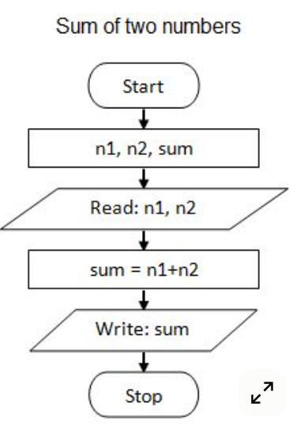

1. **Start**
2. **Input A, B**
3. **Compute SUM = A + B**
4. **Print SUM**
5. **Stop**
   1. **Find max of 2 numbers**

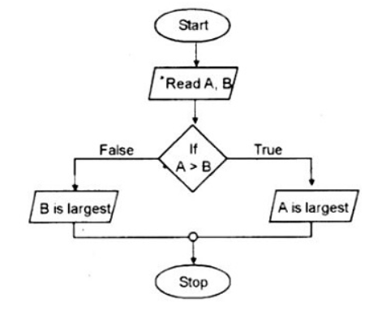

**Algorithm:**

* 1. Start
  2. Input A, B
* If A > B
* Print “A is greater”
* Else
* Print “B is greater”
  1. Stop

1. **Find if given number is odd or even**

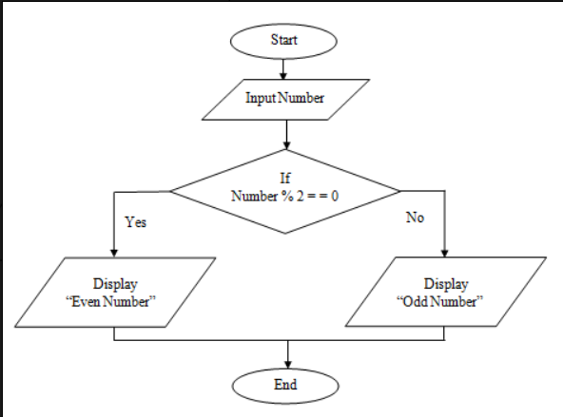

**Algorithm**

* 1. Start
  2. Input N
  3. Compute R = N % 2
  4. If R == 0 → Print “Even”  
     Else → Print “Odd”
  5. Stop

**Date:**

# Practical 3

**Aim: Design and test C programs using constants, variables, data types and different operators.**

**Code .**

#include <stdio.h>

int main() {

// Constants

const float PI = 3.14159;

// Variables

int a = 10, b = 3;

float result;

// Arithmetic operators

result = a + b;

printf("Addition: %d + %d = %.2f\n", a, b, result);

result = a - b;

printf("Subtraction: %d - %d = %.2f\n", a, b, result);

result = a * b;

printf("Multiplication: %d * %d = %.2f\n", a, b, result);

result = (float)a / b;

printf("Division: %d / %d = %.2f\n", a, b, result);

result = a % b;

printf("Modulus: %d %% %d = %.2f\n", a, b, result);

// Relational operators

printf("a > b: %d\n", a > b);

printf("a < b: %d\n", a < b);

printf("a == b: %d\n", a == b);

printf("a != b: %d\n", a != b);

// Logical operators

printf("(a > 5 && b < 5): %d\n", (a > 5 && b < 5));

printf("(a < 5 || b < 5): %d\n", (a < 5 || b < 5));

printf("!(a == b): %d\n", !(a == b));

// Using constant

printf("Value of PI constant: %.5f\n", PI);

return 0;

}

**Output**:

Addition: 10 + 3 = 13.00

Subtraction: 10 - 3 = 7.00

Multiplication: 10 * 3 = 30.00

Division: 10 / 3 = 3.33

Modulus: 10 % 3 = 1.00

a > b: 1

a < b: 0

a == b: 0

a != b: 1

(a > 5 && b < 5): 1

(a < 5 || b < 5): 1

!(a == b): 1

Value of PI constant: 3.14159

**Date:**

# Practical 4

**Aim: Design and test C programs to show formatted and unformatted input and output.**

**Code:**

#include <stdio.h>

int main() {

int age;

char name[50];

float salary;

// Formatted Input

printf("Enter your name: ");

scanf("%s", name); // formatted input for string

printf("Enter your age: ");

scanf("%d", &age); // formatted input for integer

printf("Enter your salary: ");

scanf("%f", &salary); // formatted input for float

// Formatted Output

printf("\n--- Formatted Output ---\n");

printf("Name: %s\n", name);

printf("Age: %d\n", age);

printf("Salary: %.2f\n", salary);

printf("Age: ");

putchar(age + '0'); // convert single digit integer to character (works if age < 10)

printf("\n");

printf("Salary: ");

printf("%f\n", salary); // unformatted floating point using default format

return 0;

}

**Output:**

Enter your name: John

Enter your age: 25

Enter your salary: 5000.50

--- Formatted Output ---

Name: John

Age: 25

Salary: 5000.50

--- Unformatted Output ---

Name:

John

Age: 2

Salary: 5000.500000

**Date:**

# Practical 5

**Aim: Design and test at least one C programs using below given decision making statements: (1) Simple if (2) if…else (3) Nested if (4) if…else ladder (5) switch (6) goto**

**Code**

#include <stdio.h>

int main() {

int num, choice;

// 1. Simple if

printf("Enter a number for simple if check (>0): ");

scanf("%d", &num);

if (num > 0) {

printf("Number is positive.\n");

}

// 2. if…else

printf("Enter a number for if-else check: ");

scanf("%d", &num);

if (num % 2 == 0) {

printf("Number is even.\n");

} else {

printf("Number is odd.\n");

}

// 3. Nested if

printf("Enter a number for nested if check: ");

scanf("%d", &num);

if (num != 0) {

if (num > 0) {

printf("Number is positive and non-zero.\n");

} else {

printf("Number is negative.\n");

}

} else {

printf("Number is zero.\n");

}

// 4. if…else ladder

printf("Enter a number (1-3) for if-else ladder: ");

scanf("%d", &num);

if (num == 1) {

printf("You entered One.\n");

} else if (num == 2) {

printf("You entered Two.\n");

} else if (num == 3) {

printf("You entered Three.\n");

} else {

printf("Number is out of range.\n");

}

// 5. switch

printf("Enter a number (1-3) for switch case: ");

scanf("%d", &num);

switch (num) {

case 1:

printf("Switch: One\n");

break;

case 2:

printf("Switch: Two\n");

break;

case 3:

printf("Switch: Three\n");

break;

default:

printf("Switch: Out of range\n");

}

// 6. goto

printf("Enter a number (1-3) for goto demonstration: ");

scanf("%d", &num);

if (num < 1 || num > 3) {

goto error;

}

printf("You entered %d correctly.\n", num);

return 0;

error:

printf("Error: Invalid input, out of range.\n");

return 1;

}

**Output:**

Enter a number for simple if check (>0): 5

Number is positive.

Enter a number for if-else check: 4

Number is even.

Enter a number for nested if check: -2

Number is negative.

Enter a number (1-3) for if-else ladder: 2

You entered Two.

Enter a number (1-3) for switch case: 3

Switch: Three

Enter a number (1-3) for goto demonstration: 5

Error: Invalid input, out of range.

**Date:**

# Practical 6

**Aim: Design and test C programs using the for, while and do. While loop.**

**Code**

#include <stdio.h>

int main() {

int i, n;

// 1. For loop

printf("For Loop: Enter a number n to print numbers 1 to n: ");

scanf("%d", &n);

printf("Numbers using for loop: ");

for (i = 1; i <= n; i++) {

printf("%d ", i);

}

printf("\n");

// 2. While loop

printf("While Loop: Enter a number n to print numbers 1 to n: ");

scanf("%d", &n);

i = 1;

printf("Numbers using while loop: ");

while (i <= n) {

printf("%d ", i);

i++;

}

printf("\n");

// 3. Do-While loop

printf("Do-While Loop: Enter a number n to print numbers 1 to n: ");

scanf("%d", &n);

i = 1;

printf("Numbers using do-while loop: ");

do {

printf("%d ", i);

i++;

} while (i <= n);

printf("\n");

return 0;

}

**Output:**

For Loop: Enter a number n to print numbers 1 to n: 5

Numbers using for loop: 1 2 3 4 5

While Loop: Enter a number n to print numbers 1 to n: 3

Numbers using while loop: 1 2 3

Do-While Loop: Enter a number n to print numbers 1 to n: 4

Numbers using do-while loop: 1 2 3 4

**Date:**

**Practical 7**

**Aim:Design and test a C program using break and continue statements.**

**Code**

#include <stdio.h>

int main() {

int i, n;

printf("Enter a number n: ");

scanf("%d", &n);

printf("Demonstrating break:\n");

for (i = 1; i <= n; i++) {

if (i == 5) {

printf("Break encountered at i = %d\n", i);

break; // exit loop when i is 5

}

printf("%d ", i);

}

printf("\n");

printf("Demonstrating continue:\n");

for (i = 1; i <= n; i++) {

if (i % 2 == 0) {

continue; // skip even numbers

}

printf("%d ", i);

}

printf("\n");

return 0;

}

**Output:**

Enter a number n: 7

Demonstrating break:

1 2 3 4 Break encountered at i = 5

Demonstrating continue:

1 3 5 7

**Date:**

# Practical 8

**Aim:Design and test C programs using one dimensional array and two dimensional arrays**.

**Code:**

#include <stdio.h>

int main() {

int i, j, n, rows, cols;

// One-dimensional array

printf("Enter the size of 1D array: ");

scanf("%d", &n);

int arr1D[n];

printf("Enter %d elements for 1D array:\n", n);

for (i = 0; i < n; i++) {

scanf("%d", &arr1D[i]);

}

printf("1D Array elements are: ");

for (i = 0; i < n; i++) {

printf("%d ", arr1D[i]);

}

printf("\n");

// Two-dimensional array

printf("Enter number of rows and columns for 2D array: ");

scanf("%d %d", &rows, &cols);

int arr2D[rows][cols];

printf("Enter elements for 2D array:\n");

for (i = 0; i < rows; i++) {

for (j = 0; j < cols; j++) {

scanf("%d", &arr2D[i][j]);

}

}

printf("2D Array elements are:\n");

for (i = 0; i < rows; i++) {

for (j = 0; j < cols; j++) {

printf("%d ", arr2D[i][j]);

}

printf("\n");

}

return 0;

}

**Output**:

Enter the size of 1D array: 3

Enter 3 elements for 1D array:

5

10

15

1D Array elements are: 5 10 15

Enter number of rows and columns for 2D array: 2 3

Enter elements for 2D array:

1 2 3

4 5 6

2D Array elements are:

1 2 3

4 5 6

**Date:**

# Practical 9

**Aim:** **Design and test C programs using pointers.**

**Code**

#include <stdio.h>

int main() {

int a = 10;

int b = 20;

int *ptrA, *ptrB, sum;

// Pointer initialization

ptrA = &a;

ptrB = &b;

printf("Address of a: %p, Value: %d\n", ptrA, *ptrA);

printf("Address of b: %p, Value: %d\n", ptrB, *ptrB);

// Using pointers to modify values

*ptrA = *ptrA + 5;

*ptrB = *ptrB + 10;

printf("Modified values using pointers: a = %d, b = %d\n", a, b);

// Sum using pointers

sum = *ptrA + *ptrB;

printf("Sum of a and b using pointers: %d\n", sum);

// Pointer to pointer

int **ptrPtr = &ptrA;

printf("Pointer to pointer points to value: %d\n", **ptrPtr);

return 0;

}

**Output:**

Address of a: 0x7ffee3f6a99c, Value: 10

Address of b: 0x7ffee3f6a998, Value: 20

Modified values using pointers: a = 15, b = 30

Sum of a and b using pointers: 45

Pointer to pointer points to value: 15

**Date:**

# Practical 10

**Aim: Design and C programs using user defined Functions**

**Code**

#include <stdio.h>

// Function prototypes

int add(int x, int y);

int multiply(int x, int y);

void greet(char name[]);

int main() {

int a, b;

char name[50];

// User input

printf("Enter your name: ");

scanf("%s", name);

greet(name);

printf("Enter two numbers: ");

scanf("%d %d", &a, &b);

// Using functions

printf("Sum: %d + %d = %d\n", a, b, add(a, b));

printf("Product: %d * %d = %d\n", a, b, multiply(a, b));

return 0;

}

// Function to add two numbers

int add(int x, int y) {

return x + y;

}

// Function to multiply two numbers

int multiply(int x, int y) {

return x * y;

}

// Function to greet user

void greet(char name[]) {

printf("Hello, %s!\n", name);

}

**Output:**

Enter your name: Alice

Hello, Alice!

Enter two numbers: 5 7

Sum: 5 + 7 = 12

Product: 5 * 7 = 3

**Date:**

# Practical 11

**Aim: Design and test recursion function.**

**Code**

#include <stdio.h>

// Recursive function to calculate factorial

int factorial(int n) {

if (n == 0 || n == 1)

return 1;

else

return n * factorial(n - 1);

}

int main() {

int n;

printf("Enter a number to calculate factorial: ");

scanf("%d", &n);

printf("Factorial of %d is %d\n", n, factorial(n));

return 0;

}

**Output:**

Enter a number to calculate factorial: 5

Factorial of 5 is 120

**Date:**

# Practical 12

**Aim: Design and test a C program to test various inbuilt string functions.**

**Code**

#include <stdio.h>

#include <string.h>

int main() {

char str1[50], str2[50], str3[50];

// Input strings

printf("Enter first string: ");

scanf("%s", str1);

printf("Enter second string: ");

scanf("%s", str2);

// strlen: string length

printf("Length of '%s' is %lu\n", str1, strlen(str1));

// strcpy: copy string

strcpy(str3, str1);

printf("Copied string: %s\n", str3);

// strcat: concatenate strings

strcat(str1, str2);

printf("Concatenated string: %s\n", str1);

return 0;

}

**Output:**

Enter first string: Hello

Enter second string: World

Length of 'Hello' is 5

Copied string: Hello

Concatenated string: HelloWorld

**Date:**

# Practical 13

**Aim:Design and test C programs using file operations**

**Code**

#include <stdio.h>

int main() {

FILE *fp;

char filename[50], ch;

// Input filename

printf("Enter filename to create and write: ");

scanf("%s", filename);

// Open file for writing

fp = fopen(filename, "w");

if (fp == NULL) {

printf("Error opening file!\n");

return 1;

}

// Write to file

fprintf(fp, "This is a sample text written to the file.\n");

fclose(fp);

printf("Data written to file successfully.\n");

// Open file for reading

fp = fopen(filename, "r");

if (fp == NULL) {

printf("Error opening file!\n");

return 1;

}

printf("Contents of the file:\n");

while ((ch = fgetc(fp)) != EOF) {

putchar(ch);

}

fclose(fp);

return 0;

}

**Output**

Enter filename to create and write: sample.txt

Data written to file successfully.

Contents of the file:

This is a sample text written to the file.

**Date:**

**Practical 14**

**Aim: Design and test C programs using Command line arguments**

**Code**

#include <stdio.h>

#include <stdlib.h>

int main(int argc, char *argv[]) {

if (argc != 3) {

printf("Usage: %s <num1> <num2>\n", argv[0]);

return 1;

}

int num1 = atoi(argv[1]); // convert string to integer

int num2 = atoi(argv[2]);

printf("Number 1 = %d\n", num1);

printf("Number 2 = %d\n", num2);

printf("Sum = %d\n", num1 + num2);

printf("Product = %d\n", num1 * num2);

return 0;

}

**Output**

$ gcc program.c -o program

$ ./program 5 7

Number 1 = 5

Number 2 = 7

Sum = 12

Product = 35